Letter to the Editor; Oxford Criteria: A response to Baraniuk

Fatigue, Biomedicine and Behaviour 2017: 6: 61-62

Letter to the Editor
In his recent paper in this journal [1 ] James Baraniuk claims that the Oxford Criteria for chronic fatigue syndrome (CFS) ‘grossly overestimated’ the prevalence of this disorder, stating that when applied to a nationwide survey of 6175 participants, 19.9% of females and 25.5% of males met a ‘proxy’ for the Oxford criteria [2 ]. This is surprising, not least because these figures more closely resemble countless studies of the prevalence of chronic fatigue on its own, albeit with gender differences mysteriously reversed [3].
The answer may however lie in the proxy measure chosen. Dr Baraniuk begins by saying that the Oxford criteria are ‘inappropriate’ because ‘they require only mild fatigue severity’, and goes on to define a person as fulfilling the Oxford criteria if there is ‘mild to severe symptoms of fatigue, sleep disturbance and myalgia’. In addition he ignores any exclusionary criteria, saying that ‘no weight was given to the presence or absence of any complaints’.
Unfortunately this is nothing like the actual Oxford Criteria [2 ] Fatigue must be ‘severe, disabling and affects physical and mental function’. Mild or moderate fatigue is clearly excluded. It insists that fatigue must be both mental and physical – there must be cognitive symptoms as well as physical symptoms of fatigue. There is also a duration criteria – ‘the symptom of fatigue should have been present for a minimum of six months during which it is present for more than 50% of the time’. Far from ignoring medical conditions, the criteria explicitly exclude any ‘established medical conditions known to produce chronic fatigue’. So it is clear that any known medical cause of fatigue is incompatible with the criteria. Baraniuk acknowledges this by noting that in his data the prevalence of Oxford criteria CFS declines considerably when medical exclusion criteria are used, but then chooses not to do this, even though this is mandated by the criteria. It is difficult to reconcile the actual Oxford criteria with Baraniuk’s claim that they partly select a ‘cross section of the healthy population’.
Not surprisingly, when the Oxford Criteria are applied as per definition, the prevalence of CFS is an order of magnitude lower than that found by Baraniuk. A prospective study in UK primary care [4 ], not cited in the current report, used standardized medical and psychological direct assessments, a measure designed to capture the different extant definitions of CFS at the time, including both Oxford and CDC, a check list of other symptoms and a measure of functional impairment. The results were indeed very different to those reported by Baraniuk, and in keeping with the literature since. The prevalences were also calculated with and without psychological co morbidity.
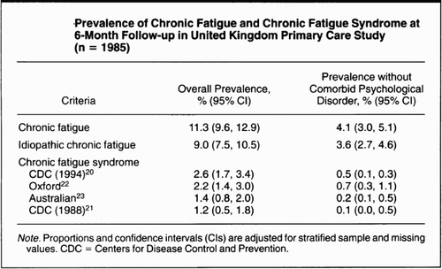
Display full size
We would respectfully submit that Baraniuk’s paper has added to the already very large literature on the prevalence of the symptom of fatigue, raises a curious anomaly in the gender distribution which remains unexplained, but says little about the Oxford criteria for CFS.

Disclosure statement
No potential conflict of interest was reported by the authors.

References
- Baraniuk J. Chronic fatigue syndrome prevalence is grossly overestimated using Oxford criteria compared to centers for disease control (Fukuda) criteria in a U.S. population study. Fatigue Biomed Health Behav. Available from: http://www.tandfonline.com/doi/full/10.1080/21641846.2017.1353578
- Sharpe MC, Archard LC, Banatavala JE, et al. Chronic fatigue syndrome: guidelines for research. J Royal Soc Med. 1991;84:118–121. doi: 10.1177/014107689108400123
- Wessely S. The epidemiology of chronic fatigue syndrome. Epidemiol Rev. 1995;17:139–151. doi: 10.1093/oxfordjournals.epirev.a036170
- Wessely S, Chalder T, Hirsch S, et al. The epidemiology of chronic fatigue and chronic fatigue syndrome - a primary care study. Am J Public Health. 1997;87:1449–1455. doi: 10.2105/AJPH.87.9.1449

